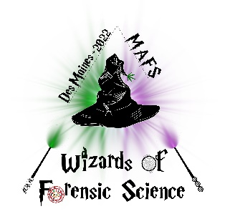
Midwestern Association of Forensic Scientists, Inc.
“A Professional, Scientific and Educational Organization”

MAFS 51st Annual Fall Meeting
September 11th through September 16th, 2022
Des Moines, Iowa

EXHIBITOR'S AGREEMENT

We wish to participate as an exhibitor at the 2022 Fall Meeting of the Midwestern Association of Forensic Scientists on September 11th - 16th at the Des Moines Marriott Downtown in Des Moines, Iowa.

We agree to pay an exhibitor's fee of $1,200, which will include one table, two chairs, and one signboard. Up to two registrations, two Thursday luncheon tickets, and two Thursday evening gala tickets will also be provided upon request. Additional registrations may be purchased at a cost of $250 per registration – additional luncheon tickets and gala tickets are also available for purchase. The exhibitors are welcome to attend the scientific sessions and hospitality hours. Any and all other expenses shall be the responsibility of the exhibitor.

Exhibitors will set up their booths on Wednesday afternoon, September 14, 2022. The exhibit area will be open to the conference attendees Wednesday evening, all day Thursday, and Friday morning. A tentative schedule of the exhibit hours can be found on the Exhibitor Information Page.

Company _____________________________________________
Address ________________________________________________________________
Phone Number ___________________________________
Email Address _________________________________________
Authorized Signature ____________________________________ Date ________________

Contact Person Information:
Name ________________________________________________
Phone Number ___________________________________
Email Address _________________________________________
# of Booth Representatives _____
# of Thursday luncheon tickets _____ # of Thursday night Gala Tickets ____
Rep Names (to appear on badges) _________________________________________
______________________________________________________________________

Electrical Requirements? □Y □N (specify) _______________________________________
Basic wireless Internet is included.

Booth space will be assigned on a first-come, first-served basis and only when full payment is made. Please make check payable to MAFS, Inc. Be advised that $100 of the exhibitor’s fee is non-refundable and no refunds will be made after August 8, 2022.

Contact: Brandy Cline, Exhibitor Chair Mail Checks to: Allison King
Indiana State Police Laboratory 3157 Frontier Dr
550 W. 16th Street, Suite C Woodbury, MN 55129
Indianapolis, IN 46202
(317) 921-5378
bcline@isp.in.gov

